|  |  |
| --- | --- |
| **Module Code** | **CN 7201** |
| **Module Title** | **Advanced Software Engineering** |
| **LSBF Coursework Instructor** | **Mr Francis Ho(FT) and Mr William Ku (PT)** |
| **Coursework Title** | **Live Applied Advanced Software Engineering Project (3000 Words)** |
| **Weighting** | 50% |
| **Handout Date** | **20February 2024** |
| **Coursework Submission Date** | **09 May 2024** |
| **Students’ Name & Students’ ID** | |  |  | | --- | --- | | **Student Name(s)** | **Student ID Number(s)** | | Xu Yifan | S1034436 | | Ge Zongqi | S1033870 | | Hu Jin | S1030125 | | Yu Wenhao | S1033236 | |
| **Documents uploaded in LSBF Canvas:** | ⭘ Assignment Report  ⭘ Presentation Report  ⭘ Source Code, Scripts & Output  ⭘ Turnitin Report |
| **UEL Turnitin Submission Similarity Index %** |  |
|  | |

**Abstract**

**Because the traditional educational administration information management system is difficult, the fault tolerance rate is low, the management personnel processing data time and labor, in order to solve this problem, the development of this educational administration system can solve many problems.**

**The functions of the educational administration information platform include course type management, grade information management, course selection information management, teacher management, course information management, class schedule information management and so on. The system uses Mysql database, Java language, SSM framework and other technologies to implement programming.**

**Educational administration information platform can improve the efficiency of solving educational administration information management problems, optimize the process of educational administration information processing, and ensure the safety of educational administration information data. It is a very reliable and safe application program.**

**Key words: Educational administration information platform; Mysql database; Java language**

**Table of Contents**

[1. Introduction 7](#_Toc27754)

[2. Project background 7](#_Toc915)

[2.1. Project Purpose 9](#_Toc1006)

[2.2. Purpose and Objectives 9](#_Toc13127)

[3. Educational Administration system -- Current system 10](#_Toc20017)

[4. Feasibility Analysis 12](#_Toc5122)

[4.1. Technical Feasibility 12](#_Toc2706)

[4.2. Economic Feasibility 12](#_Toc27594)

[4.3. Operation Feasibility 12](#_Toc25240)

[5. Demand analysis and specification 13](#_Toc13115)

[5.1. Use case diagram 13](#_Toc21725)

[5.2. Use Case Description 17](#_Toc23883)

[5.3. Recommended System Requirements 20](#_Toc17458)

[5.4. State diagram 21](#_Toc30293)

[6. System and programming/prototyping 23](#_Toc13592)

[6.1. Educational Administration Management system domain class diagram and explanation 23](#_Toc7227)

[6.2. Class diagram and description of educational administration management system 23](#_Toc21437)

[6.3. Sequence diagram and explanation of educational administration management system 25](#_Toc8419)

[6.3.1 Time sequence of the login page 25](#_Toc28445)

[6.3.4Score query time sequence diagram 28](#_Toc29023)

[6.3.5 Timing diagram of course selection 28](#_Toc14842)

[6.4. Sequence diagram and description of educational administration management system 30](#_Toc28534)

[6.5. Architecture diagram and description of the educational administration management system 32](#_Toc26823)

[6.6. Course selection system activity diagram 33](#_Toc6261)

[7. User interface design/modeling and testing 34](#_Toc15292)

[7.1. User interface model of educational administration management system 34](#_Toc27492)

[8. Test plan, test examples and results 39](#_Toc16039)

[8.1. Algorithm trial operation, demonstration and discussion 39](#_Toc21018)

[8.2. Test flow chart 40](#_Toc5182)

[9. Dependencies 41](#_Toc11208)

[9.1. Critically discuss the educational administration system 41](#_Toc4344)

[9.2. Risk Analysis 41](#_Toc19691)

[10. conclusion 41](#_Toc18873)

[11. Practical inspiration and future research development 42](#_Toc10186)

[11.1. Practical inspiration 43](#_Toc7381)

[11.2. Future development study 43](#_Toc10731)

[12. References 44](#_Toc12342)

[13. Appendix 46](#_Toc32289)

[Annex B: Gantt Charts 46](#_Toc30122)

**List of Figures**

[Figure1.0 Overall flow chart 9](#_Toc5288)

[Figure2.0 Education Administration system 11](#_Toc13036)

[Figure3.0 Total use case diagram of educational administration system 13](#_Toc2503)

[Figure4.0 Use case diagrams for teachers and students 14](#_Toc16821)

[Figure5.0 Administrator use Case Diagram 15](#_Toc12316)

[Figure6.0 Course selection system use case diagram 16](#_Toc27642)

[Figure7.0 Score query system use case diagram 17](#_Toc23498)

[Figure8.0 View results-student State diagram 21](#_Toc23827)

[Figure9.0 View results-teacher State diagram 22](#_Toc20220)

[Figure10.0 Educational Administration Management system domain class diagram and explanation 23](#_Toc8229)

[Figure11.0 Class diagram and description of educational administration management system 24](#_Toc24433)

[Figure12.0 Time sequence of the login page 25](#_Toc21224)

[Figure13.0 Students change the information timing diagram 26](#_Toc18271)

[Figure14.0 Timing Diagram of Administrator and Teacher rights 27](#_Toc5270)

[Figure15.0 Score query time sequence diagram 28](#_Toc10125)

[Figure16.0 Timing diagram of course selection 29](#_Toc20356)

[Figure17.0 Sequence diagram and description of educational administration management system 31](#_Toc767)

[Figure18.0 Architecture diagram and description of the educational administration management system 33](#_Toc15518)

[Figure19.0 Course selection system activity diagram 34](#_Toc20735)

[Figure20.0 User interface model of educational administration management system 35](#_Toc22481)

[Figure21.0 Educational management system main page 35](#_Toc8298)

[Figure22.0 Administrator interface 36](#_Toc29855)

[Figure23.0 Teacher interface 36](#_Toc24173)

[Figure24.0 Student interface 37](#_Toc23665)

[Figure25.0 Course selection system interface 37](#_Toc9230)

[Figure26.0 Course information 37](#_Toc27751)

[Figure27.0 Class schedule information 38](#_Toc18753)

[Figure29.0 Landing page 39](#_Toc5809)

[Figure30.0 Test code 39](#_Toc12630)

[Figure31.0 Test code 40](#_Toc3004)

[Figure32.0 Test flow chart 40](#_Toc9205)

# Introduction

With the continuous development of the education field, the educational administration system has changed from the traditional manual operation to the modern management relying on advanced technology(Jacobson et al., 2011). As a professional educational management tool, educational administration system is being widely used in schools and educational institutions at all levels to improve teaching efficiency(Larman, 2005). Optimize resource allocation and enhance student learning experience(Dai et al., 2021).

Educational management system is a software system designed specifically for schools or educational institutions to help administrators, teachers, and students manage teaching activities and student information more effectively(Chen, 2014):

Course Management: Allows faculty and staff to create, edit, and manage course information such as course codes, names, credits, instructors, etc.

Student information management: record and maintain students' basic information, contact information, course selection, grades and other data.

Teacher information management: record teachers' personal information, taught courses, office hours, etc.

Grade Management: Record and manage student grades, including tests, assignments, quizzes, etc.

Teaching resource management: management and allocation of classroom, laboratory, library resources, etc.

Scheduling management: Automatic or manual scheduling of courses based on course, teacher, and classroom resources.

Report and analysis: Generate all kinds of teaching statistics reports to assist management in decision-making.

Notice Announcements: Release important notices or announcements to specific groups or to all users.

The implementation of the educational administration management system can improve the efficiency of teaching management, reduce manual operation errors, optimize the utilization of resources, and provide the basis for the strategic planning of the school through data analysis(Ross et al., 2016).

# Project background

With the development of information technology, the field of education is undergoing changes. The traditional educational administration system has been unable to meet the increasing demands of teaching and the complex and changeable educational environment. The information of educational administration has become a key way to improve the quality of teaching and the efficiency of educational administration. Educational administration system, as a professional educational management software, provides one-stop educational administration management services and realizes the automatic and intelligent educational administration process by means of information. It greatly improves the efficiency and accuracy of educational administration.

The background of the educational administration management system project mainly stems from the need to improve the efficiency of educational administration and the desire to build a digital campus environment. In today's information-based social background, the digital transformation in the field of education is also accelerating, among which educational administration management system, as the core part of school management, has a particularly urgent need for digitalization and informationization(Schürr et al., 2012).

First of all, the construction of educational administration management system can effectively improve the work efficiency of educational administration personnel and teaching leaders, reduce repetitive labor and reduce the error rate by means of information technology, and make educational administration work more standardized and scientific.

Secondly, the construction of educational administration management system is also an important part of the realization of "digital campus", which can be seamlessly connected with other systems (such as student information system, financial system, etc.) to achieve information sharing and unified management, avoiding information islands and redundant operations.

In addition, the educational administration management system can also provide data support for the school's decision-making, and provide reliable data basis for the school's strategic planning through the optimal allocation of teaching resources and the monitoring and evaluation of teaching quality.

However, the construction of educational administration management system also faces some challenges, such as project implementation time, cost control, demand change processing, security policy formulation, etc., which need to be fully considered and planned at the beginning of the project(Soni et al., 2017).

## Project Purpose

The main objectives of the educational Administration system are:

Improve the efficiency of educational administration and reduce manual errors

To realize the reasonable arrangement of courses

Timely access to teaching information and grade feedback

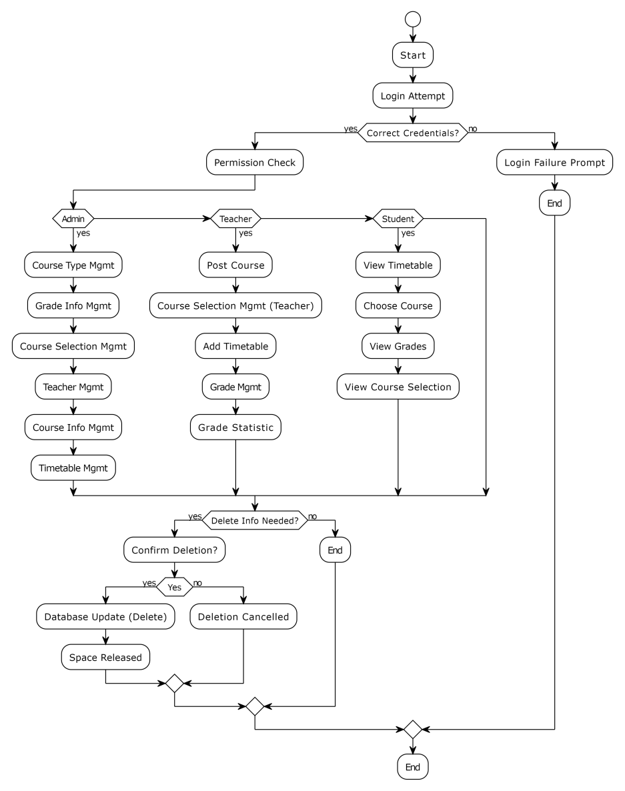

**Figure1.0** Overall flow chart

## Purpose and Objectives

Improve the level of educational administration

We will promote the sustained development of education

# Educational Administration system -- Current system

The flow chart of educational administration management system mainly describes the sequence and logical relationship of each key link in the educational administration management system. Generally includes the following core parts:

Data import and management: including the import and maintenance of student information, teacher information, course information and classroom resources.

Scheduling and publishing: Automatically or manually scheduling class schedules according to course Settings, classroom resources and teacher schedules, and publishing class schedules to teachers and students.

Course selection and adjustment: Students choose courses according to their personal interests and professional requirements, and systematically deal with course selection conflicts and course quotas.

Grade management: Teachers input student grades, and the system records and saves grade information.

Query and report: Provide a variety of query functions, such as viewing the curriculum, grades, etc., and generate the corresponding report.

System maintenance and upgrade: Periodically back up data, update the system, and maintain security.

The flowchart connects each step through the arrow, clearly shows the process and sequence of educational administration, which helps to optimize the educational administration process and improve the efficiency of teaching management.

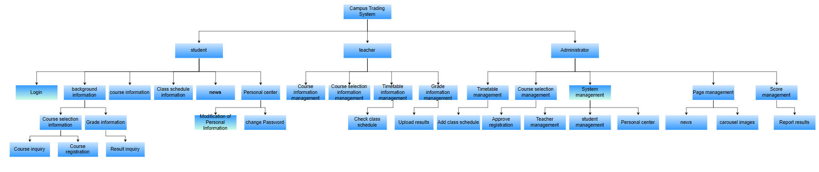

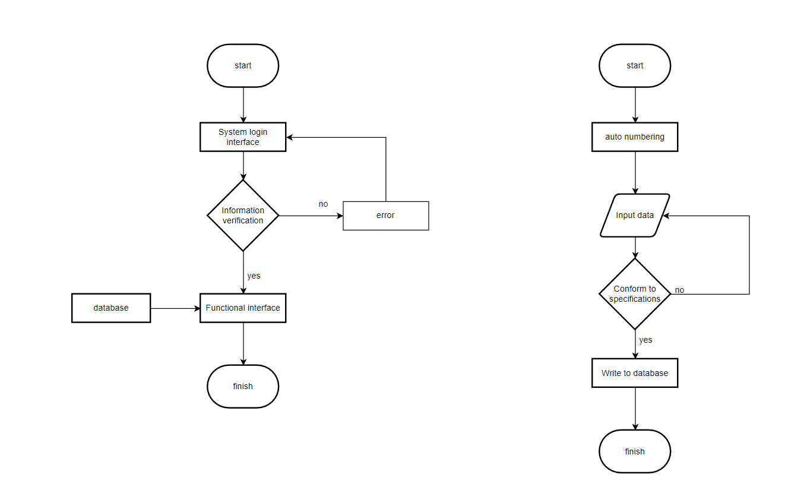

**Figure2.0 Education Administration system**

# Feasibility Analysis

## Technical Feasibility

Educational systems can use database management systems such as MQSQL or Oracle to store and manage data

## Economic Feasibility

The development and maintenance of educational administration system requires a certain amount of investment, but automated educational administration can reduce labor costs, improve work efficiency and reduce error rate.

## Operation Feasibility

The educational administration system is designed to be as simple and intuitive as possible so that teachers and students can learn and use it quickly, while providing guidelines for use

# Demand analysis and specification

## Use case diagram

### 5.1.1 Total use case diagram of educational administration system

The main elements are use cases, participants and systems. The educational administration system use case diagram is a graphical tool used to show system functions and user interactions. It is mainly used to describe how different users in the educational administration system interact with the system to complete specifictasks

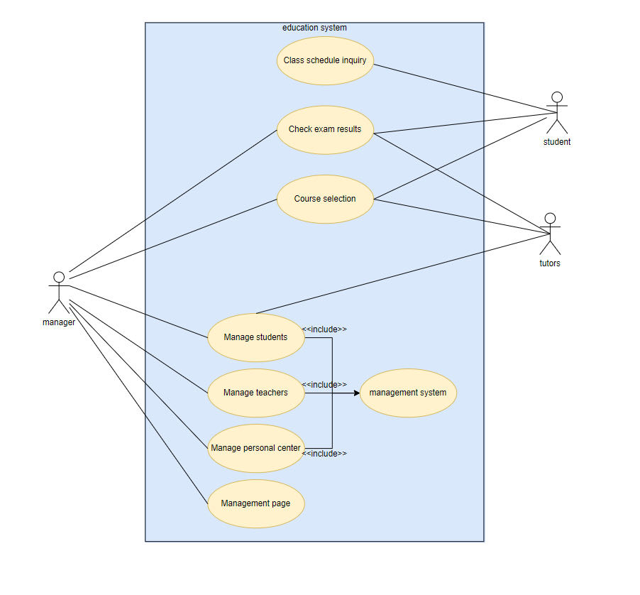

Figure3.0 Total use case diagram of educational administration system

### 5.1.2 Use case diagrams for teachers and students

Student access to educational administration management system use case diagram includes teacher access to educational administration system use case diagram includes

**1. Students log in to system 1. Teacher login system**

**2. Students view course information 2. Teacher selection of course**

**3. Students check their grades 3. The teacher entered the student's grades**

**4. Students select courses and register 4. Teachers provide grade updates**

**5. Students check their personal course schedule**

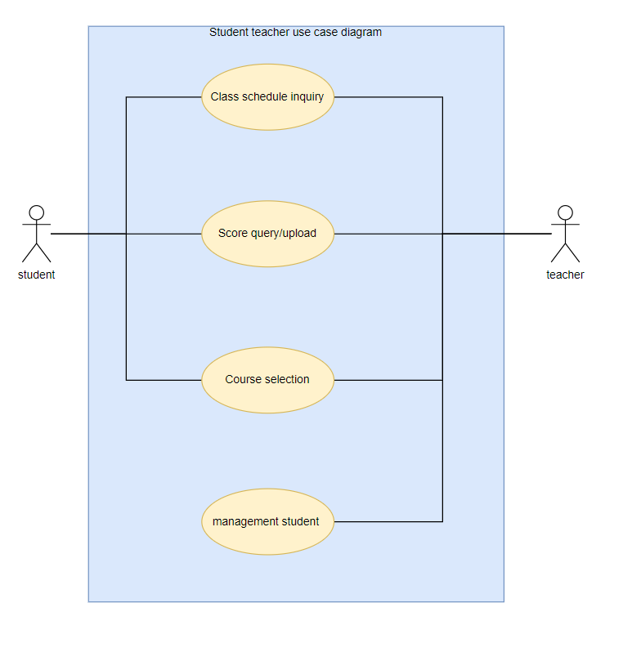

**Figure4.0 Use case diagrams for teachers and students**

### 5.1.3 Administrator use Case Diagram

Administrators first need to use their own user name and password to log in to the educational administration system, after logging in the administrator can query the system running status... Administrators can also add and delete courses, as well as edit existing courses. Administrators need to assign teachers to appropriate courses. When users report errors, administrators need to view and resolve the problem. The administrator has the right to create new users. After all operations are complete, the administrator can safely exit the system

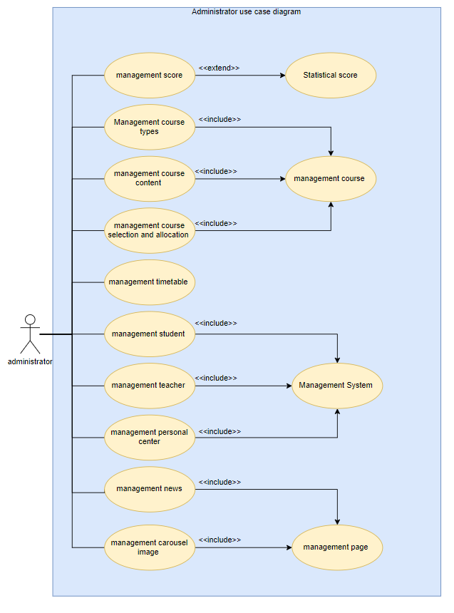

**Figure5.0 Administrator use Case Diagram**

### 5.1.4 Course selection system use case diagram

Students log in to the educational affairs system to select courses, view the list of available courses and select courses to submit the course selection request

Teachers Add courses Enter the course information and submit it

Administrators log in to the system to view all course information, add or delete courses

Students, teachers, and administrators can search for specific course information

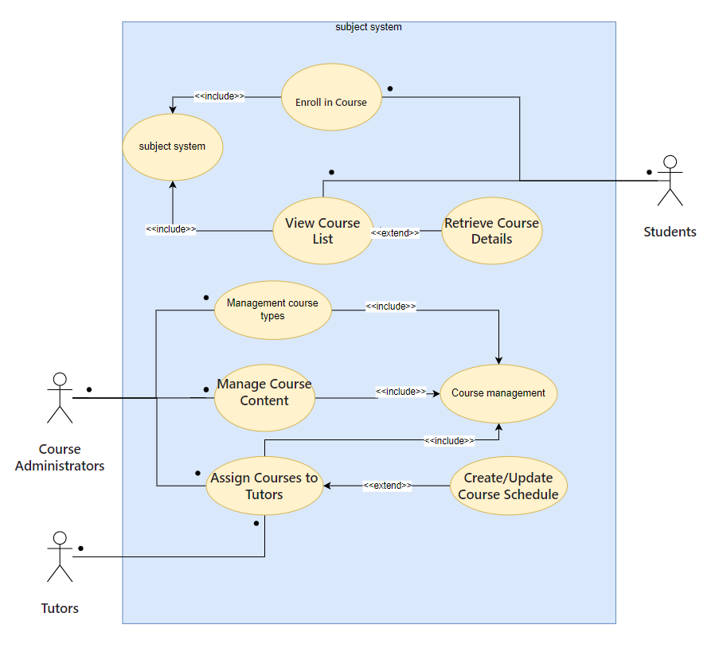

Figure6.0 Course selection system use case diagram

### 5.1.5 Score query system use case diagram

Students log in to the academic affairs system to check their scores for specific courses

Teachers and administrators enter grades and secondary confirmation information, and scores appear in the system

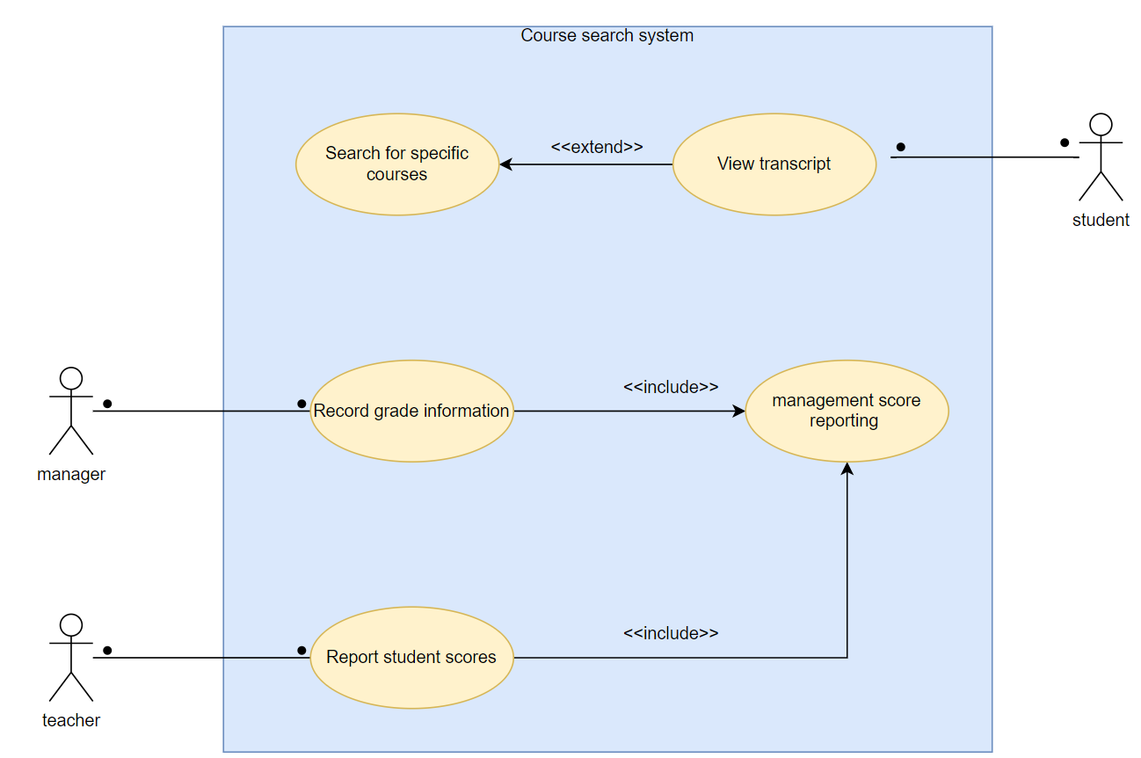

Figure7.0 Score query system use case diagram

## Use Case Description

### 5.2.1 Course selection system use case description

|  |  |
| --- | --- |
| **USE CASE DESCRIPTION** | |
| **SYSTEM** | **subject system** |
| **USE CASE NAME: Students choose courses** | |
| **PRIMARY ACTORS**  ****Students**** | **OTHER ACTORS**  ****Course Administrators****  ****Tutors**** |
| **STAKEHOLDERS** |  |
| **DESCRIPTION**  **Students log in to the system, check the course list and course type after logging in, search for courses in the optional list, and register for the course** | |
| **RELATIONSHIPS**  **INCLUDES:**  **Enroll in Course (includes) View Course List**  **Enroll in Course (includes) Retrieve Course Details**  **Manage Course Content (includes) Assign Courses to Tutors**  **EXTENDS:**  **View Course List (extends) Retrieve Course Details**  **Manage Course Content (extends) Create/Update Course Schedule**  **DEPENDS ON:**  **NA** | |
| **INPUT: Username, Password, student ID, course ID** | |
| **PRE-CONDITIONS:**  **Students and tutors have registered in the system and the course already exists** | |
| **STEPS:** | |
| **ACTOR** | **SYSTEM** |
| **1.student Login to the system with**  **username and password.** | **2.System Validates the Patient Login and Redirect**  **them to the Main Page.** |
| **3.Students view course list** | **4.Show all course information** |
| **5.Students get course details** | **6.Show course details** |
| **7.Students submit registration applicatio**n | **8.Check submitted student and course status** |
| **9.The program administrator approves the registration application** | **10.Save registration information** |
| **ALTERNATIVES AND EXCEPTIONAL FLOWS:**   1. **The student has registered for the course and the course is full** 2. **Course does not exist** 3. **New content is malformed** 4. **Tutor assigned course** 5. **schedule conflict** | |
| **POST CONDITIONS**  **Registration successful, students join the course** | |

### 5.2.2 Use case description of the score query system

|  |  |
| --- | --- |
| **USE CASE DESCRIPTION** | |
| **SYSTEM** | **Course search system** |
| **USE CASE NAME: Search course grades** | |
| **PRIMARY ACTORS student** | **OTHER ACTORS manager teacher** |
| **STAKEHOLDERS** |  |
| **.DESCRIPTION**  **This use case allows students to find grades for courses they are interested in in a grade search system. Students can filter results using different search criteria, such as course code, course name, or instructor name.** | |
| **RELATIONSHIPS**  **INCLUDES:**  **"Record grade information" contains "Score reporting management"**  **"Report student scores" contains "Score reporting management"**  **EXTENDS:**  **"Search for specific courses score" extend "View transcript"**  **DEPENDS ON:** | |
| **INPUT:**  **search condition**  **Student login credentials** | |
| **PRE-CONDITIONS:**  **The student has logged into the grade search system.**  **There is at least one course record available in the system.** | |
| **STEPS:** | |
| **ACTOR** | **SYSTEM** |
| **Students open the grade search system** | **Navigate to the search page** |
| **Students enter their search criteria and click the "Search" button to submit their query** | **Filter the course list and display matching results** |
| **View transcript** |  |
| **ALTERNATIVES AND EXCEPTIONAL FLOWS:**  **If students do not enter any search criteria, the system can provide a default search result or prompt students to enter valid search criteria.**  **If a course that matches the student's search criteria does not exist in the system, the system displays a message informing the student that no matching course was found.** | |
| **POST CONDITIONS**  **Students can continue browsing other course grades or exit the search function.** | |

## Recommended System Requirements

### 5.3.1 Service architecture of Educational affairs system

The service architecture of educational administration system mainly includes three levels: presentation layer, logic layer and data layer

## State diagram

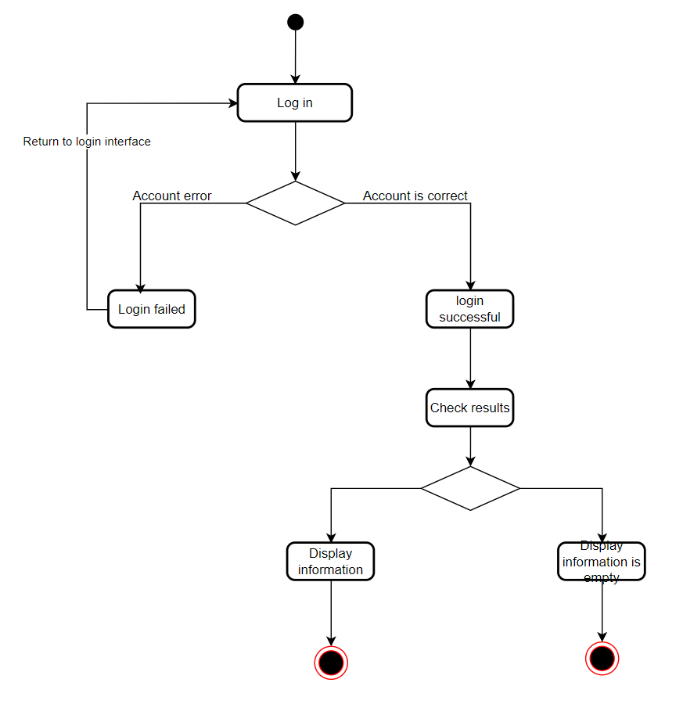

Figure8.0 View results-student State diagram

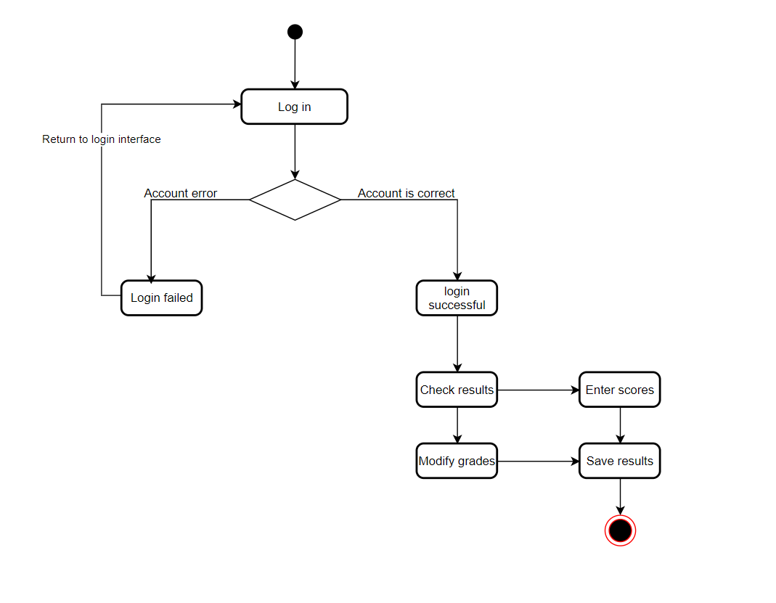

Figure9.0 View results-teacher State diagram

# System and programming/prototyping

## Educational Administration Management system domain class diagram and explanation

The main categories of educational administration systems are students, teachers, administrators,

Student class, Teacher class, Administrator class, Achievement class, Curriculum class,

**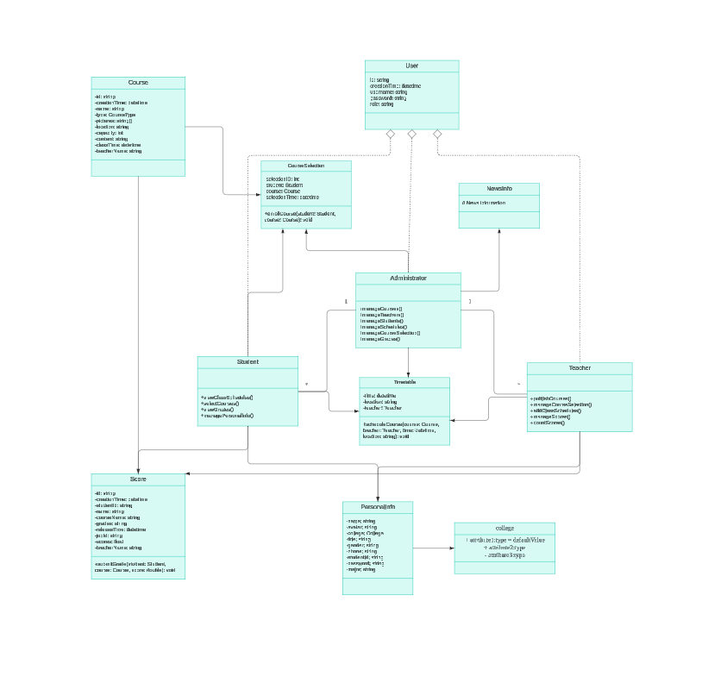**

Figure10.0 Educational Administration Management system domain class diagram and explanation

## Class diagram and description of educational administration management system

The system displays the properties, classes, and relationships between these classes in this application

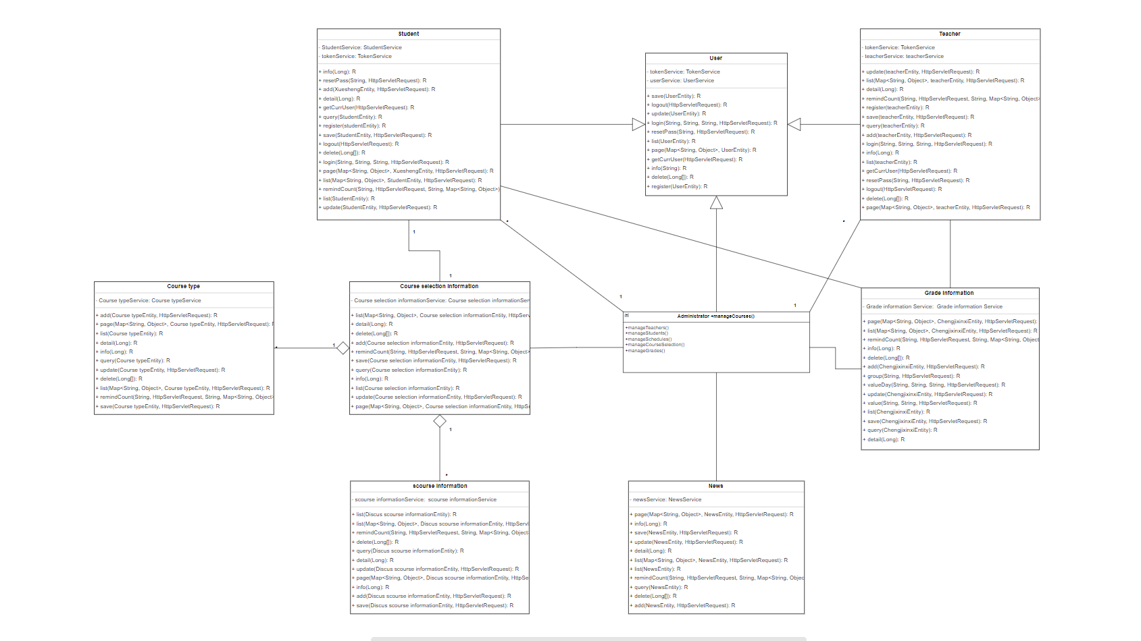

Figure11.0 Class diagram and description of educational administration management system

## Sequence diagram and explanation of educational administration management system

### 6.3.1 Time sequence of the login page

The sequence diagram shows the user login process

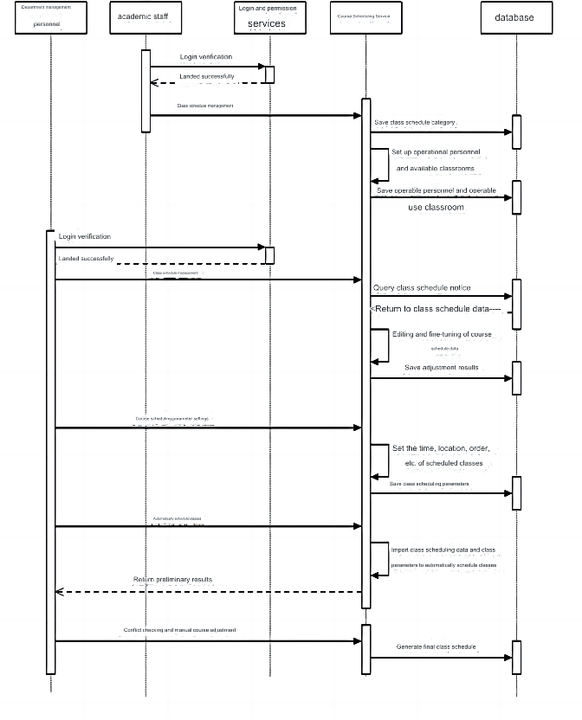

Figure12.0 Time sequence of the login page

### 6.3.2 Students change the information timing diagram

At this time, the sequence diagram shows the process of the student modifying the information and password

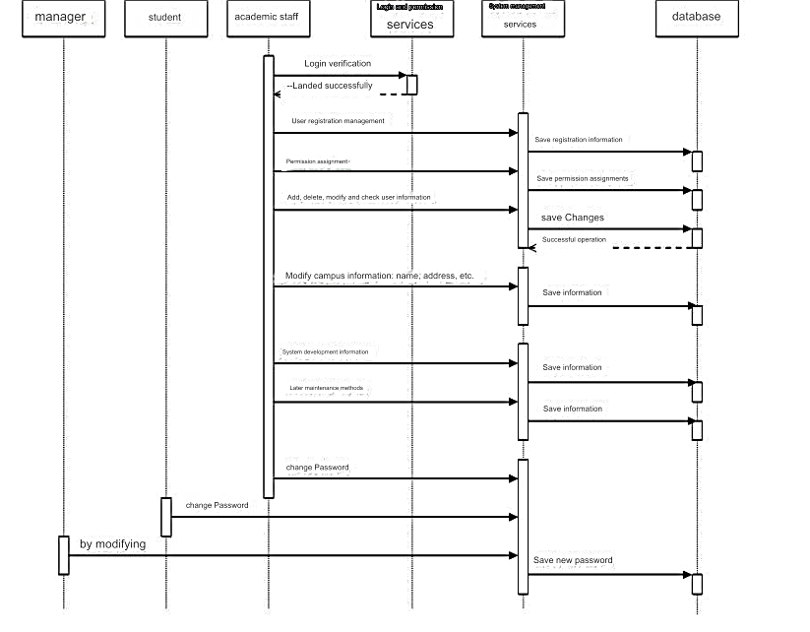

Figure13.0 Students change the information timing diagram

### 6.3.3 Timing Diagram of Administrator and Teacher rights

The sequence diagram shows the process by which teachers and administrators modify and submit course information

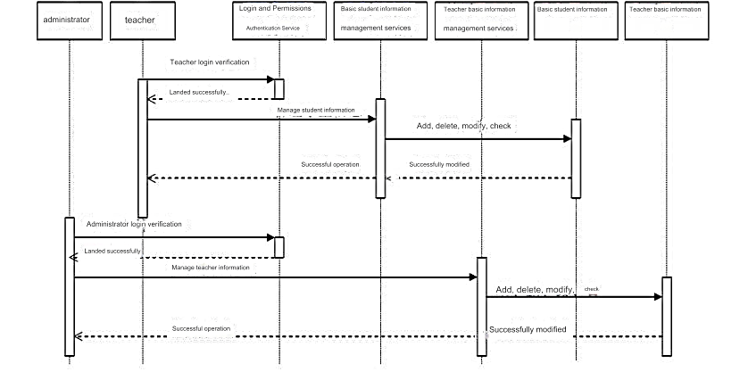

Figure14.0 Timing Diagram of Administrator and Teacher rights

### 6.3.4Score query time sequence diagram

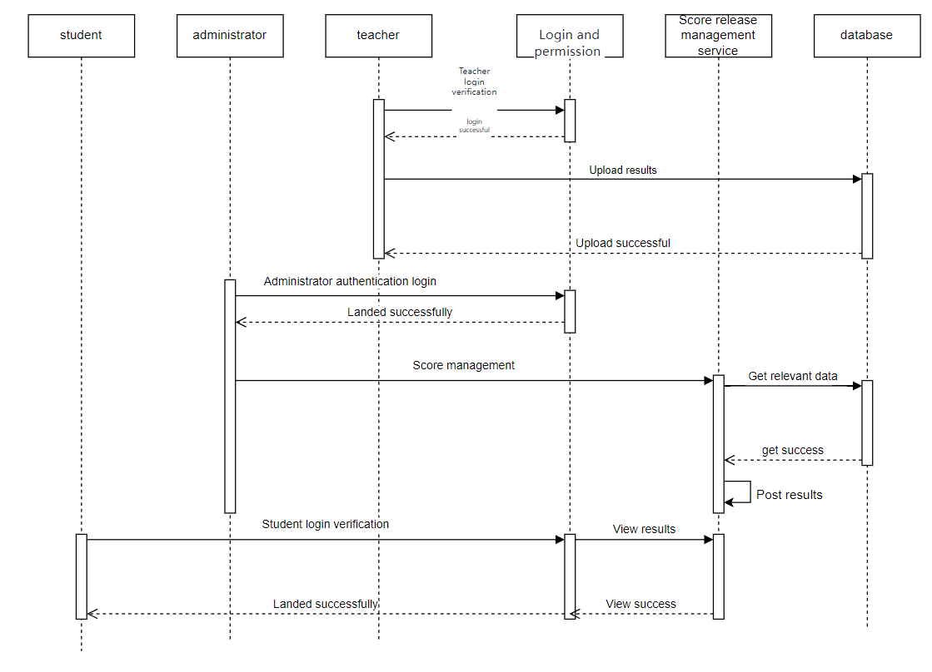

Figure15.0 Score query time sequence diagram

### 6.3.5 Timing diagram of course selection

The sequence diagram shows the process by which students select courses and submit them

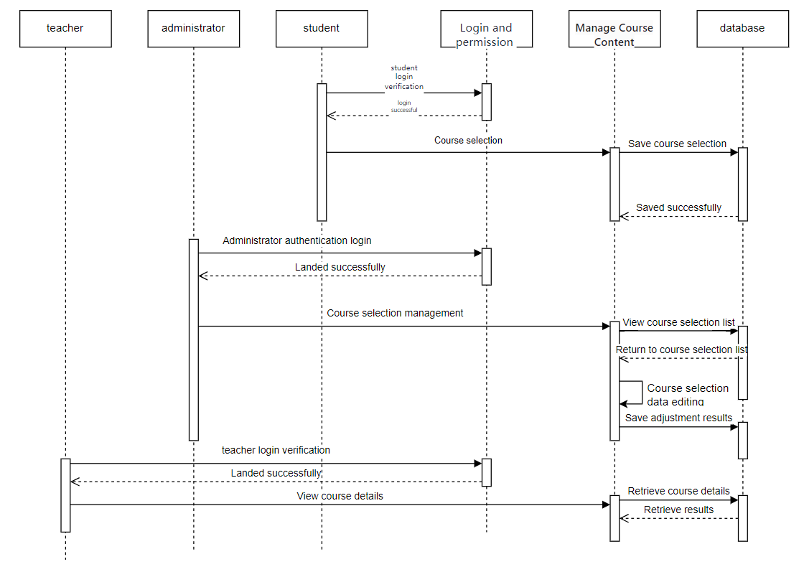

Figure16.0 Timing diagram of course selection

## Sequence diagram and description of educational administration management system

The sequence diagram of the educational administration management system shows the interactive relationship and operation process between various objects in the system:

Login: Users (such as students, teachers, or administrators) first need to log into the system and enter a username and password for authentication.

Query information: After logging in successfully, users can query course information, student information, grades and so on.

Course selection: Students can choose courses according to their needs and curriculum.

Teaching: Teachers teach according to the curriculum.

Grading and evaluation: Teachers grade students' assignments, exams, and evaluate how well students are learning.

Update information: The administrator is responsible for maintaining and updating the data in the system, including adding new courses, new student records, etc.

System management: Administrators also need to perform routine management and maintenance of the system to ensure the normal running of the system.

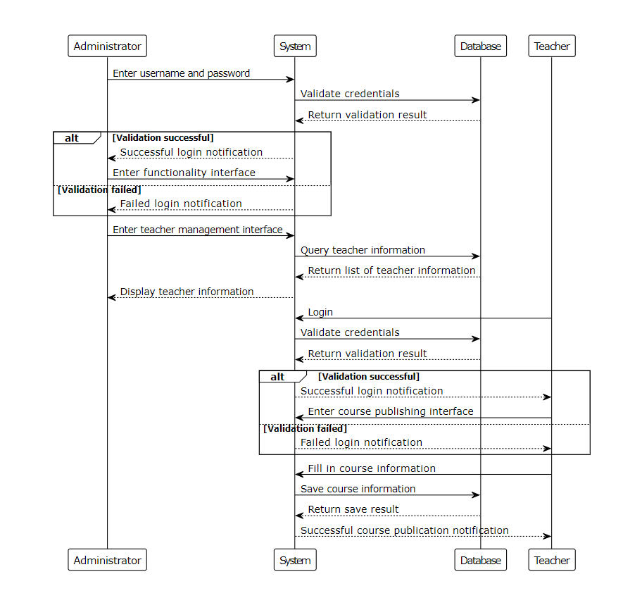

Figure17.0 Sequence diagram and description of educational administration management system

## Architecture diagram and description of the educational administration management system

The architecture diagram of educational administration management system is mainly divided into three layers: presentation layer, application layer and data layer.

Presentation layer (front-end) : This layer is the user interface, including web pages, mobile applications, etc., for users to interact with the system, such as login, registration, viewing course information, selecting courses, viewing grades, etc.

Application layer (middleware) : This layer is the core part of the system, including business logic processing, service scheduling, etc. It receives requests from the presentation layer, processes business logic, and interacts with the data layer.

Data layer (back-end) : This layer mainly includes databases and file storage systems, which are used to store all system data, such as student information, teacher information, course information, grade information, etc.

On the basis of this three-layer structure, the educational administration management system also includes the following key modules:

User management module: Used to manage user accounts, permissions and other information.

Course management module: It is used to manage the creation, modification and deletion of courses.

Course selection management module: It is used for students to select courses, withdraw courses and other operations.

Grade management module: used for teachers' grades and scores input, query and other operations.

System management module: Used by the administrator to manage the system, such as backup, recovery, and user rights assignment.

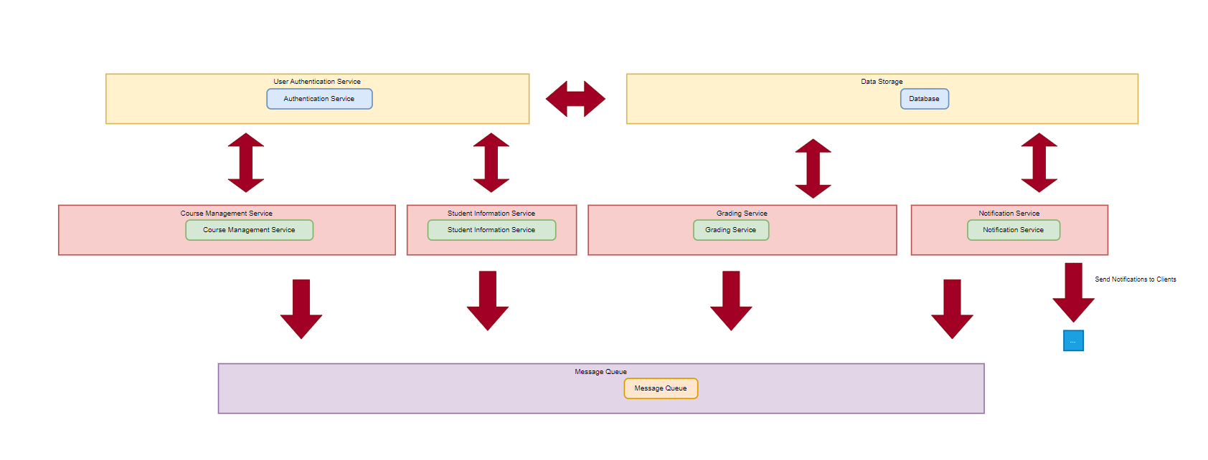

**Figure18.0 Architecture diagram and description of the educational administration management system**

## Course selection system activity diagram

In the developed academic information platform, course selection activities serve as a core functional module that closely connects students, teachers and course management, aiming to provide a convenient and efficient course selection experience. The design of this module focuses on key aspects such as students' independent course selection, course information inquiry, time conflict detection, quota restrictions, and teacher review. It ensures that each student can smoothly plan a personalized learning schedule, and also facilitates teachers and academic administrators to monitor course selection dynamics. , Maintain teaching order. Here are detailed step-by-step instructions:

1Student enters course information

2 Administrator Verification Course

3 Create emergency courses

4 Determine the legality of adding courses

5Add courses to database

6 Determine whether adding the course is successful

7 Display added course information

8 Prompt to re-enter

9 Show add error message

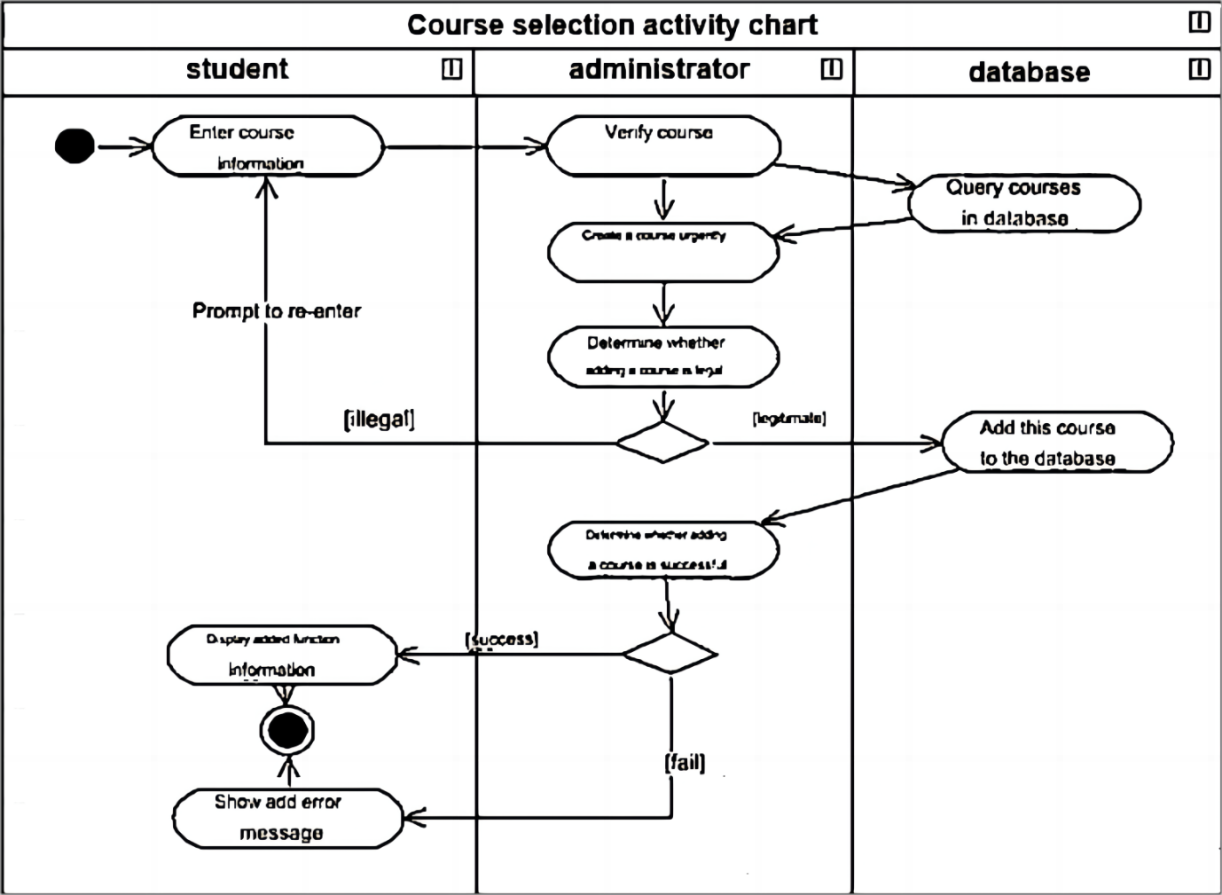

Figure19.0 Course selection system activity diagram

# User interface design/modeling and testing

## User interface model of educational administration management system

In order for users to intuitively feel the experience of the educational administration management system, we created a model to visualize how the system operates. The educational administration system is shown in the screenshot below.

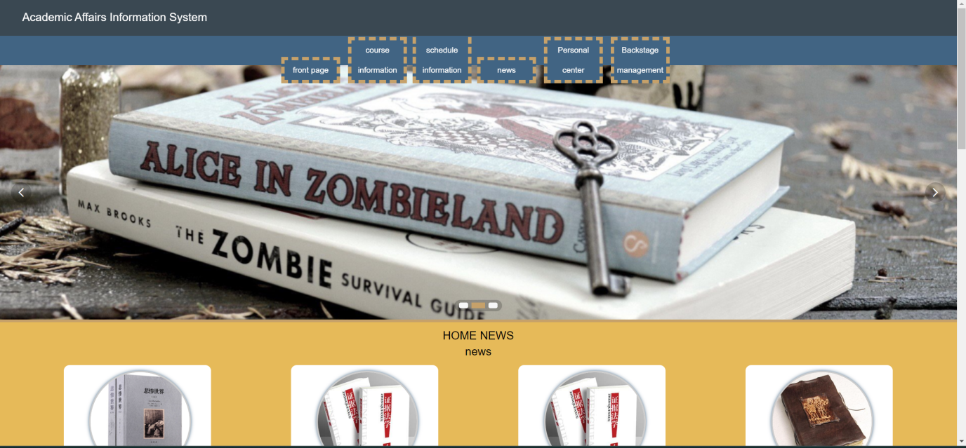

Figure20.0 User interface model of educational administration management system

1Educational management system main page

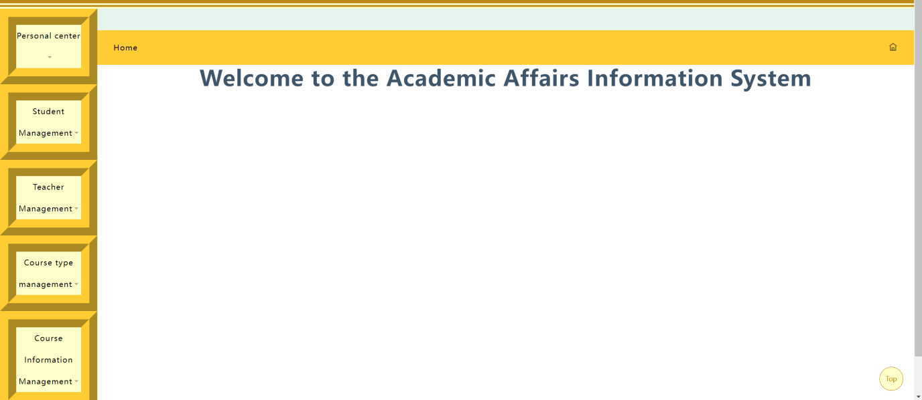

Figure21.0 Educational management system main page

2Administrator interface

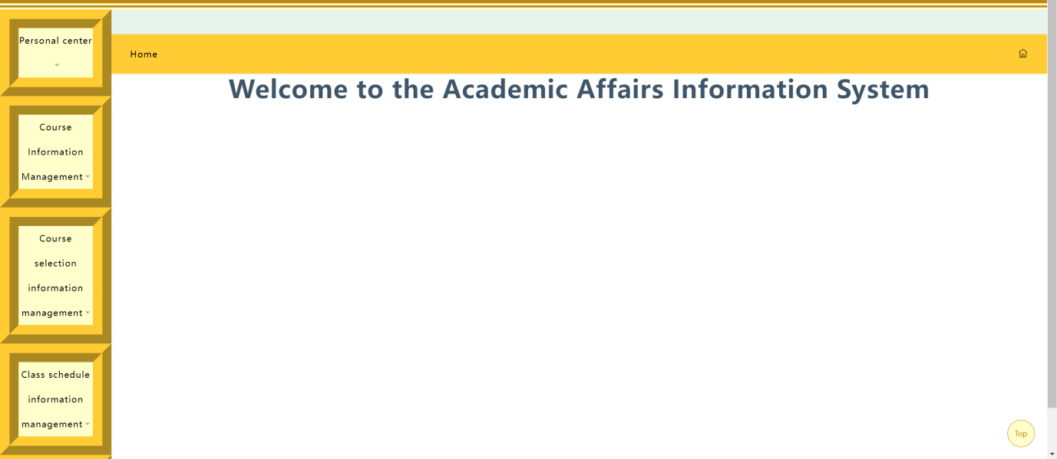

Figure22.0 Administrator interface

3Teacher interface

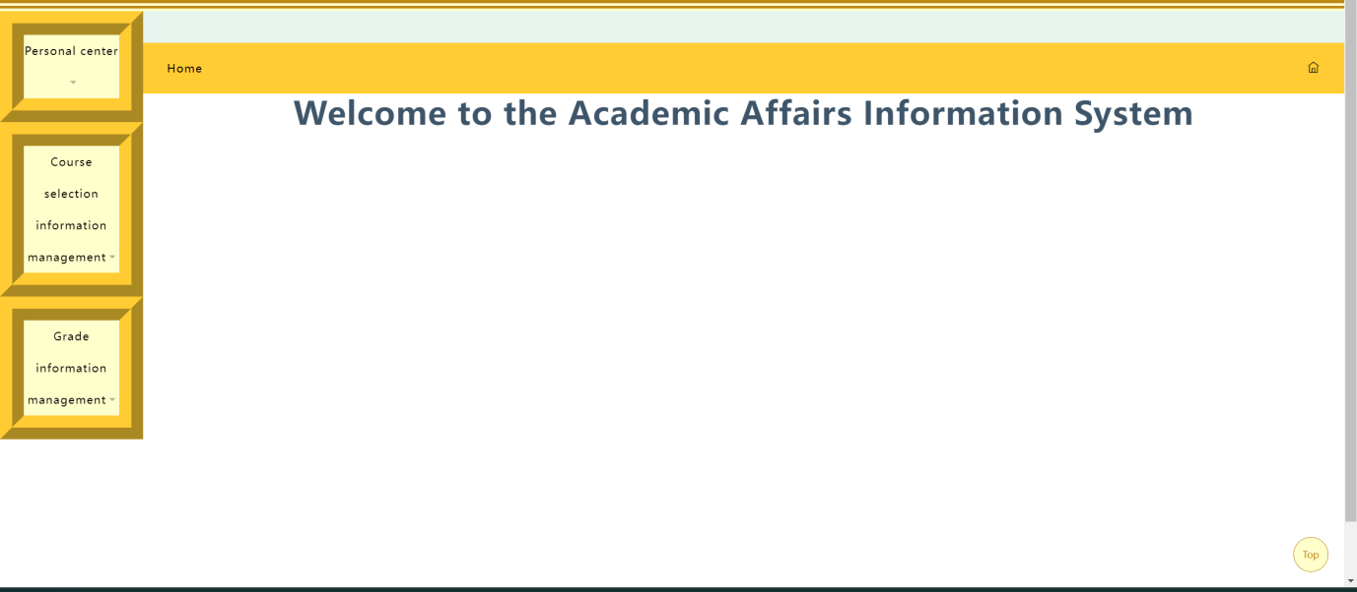

Figure23.0 Teacher interface

4Student interface

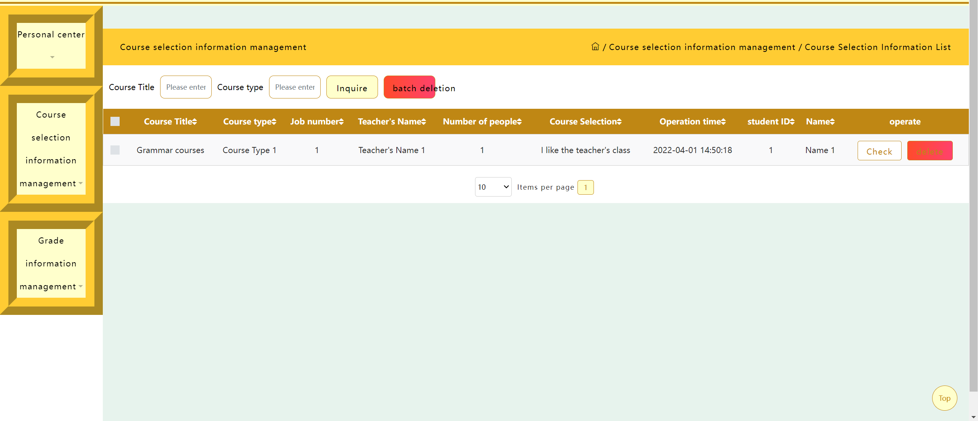

Figure24.0 Student interface

5Course selection system interface

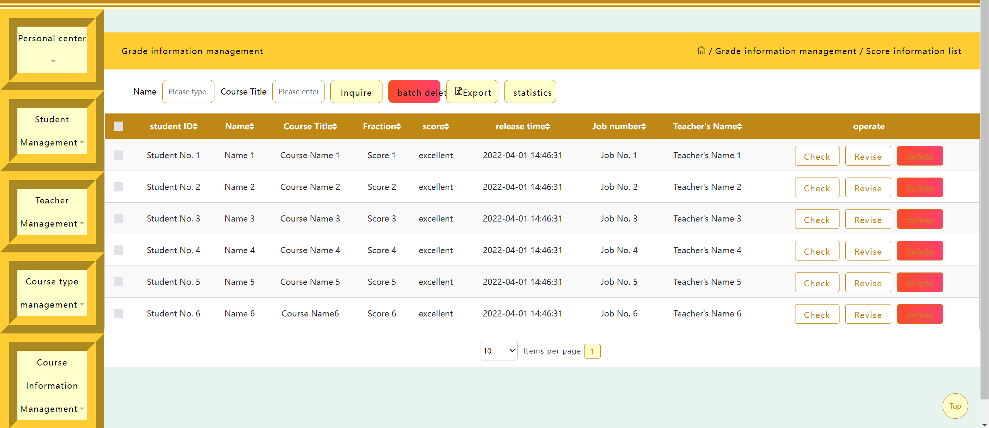

Figure25.0 Course selection system interface

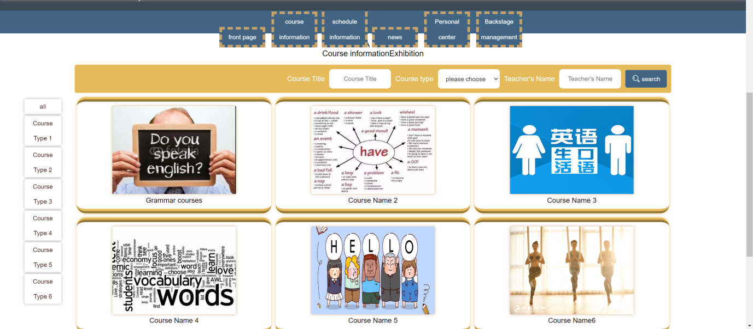

Figure26.0 Course information

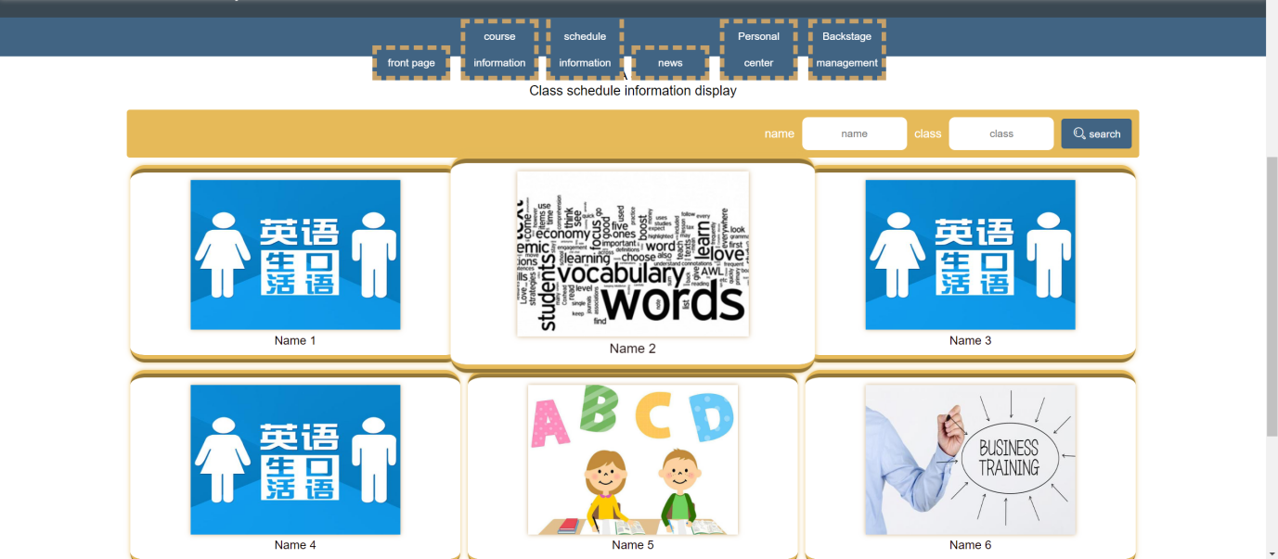

Figure27.0 Class schedule information

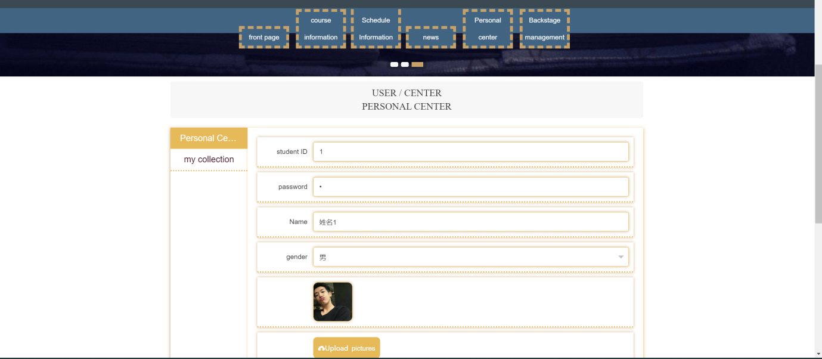

**Figure28.0 Individual center**



Figure29.0 Landing page

# Test plan, test examples and results

## Algorithm trial operation, demonstration and discussion

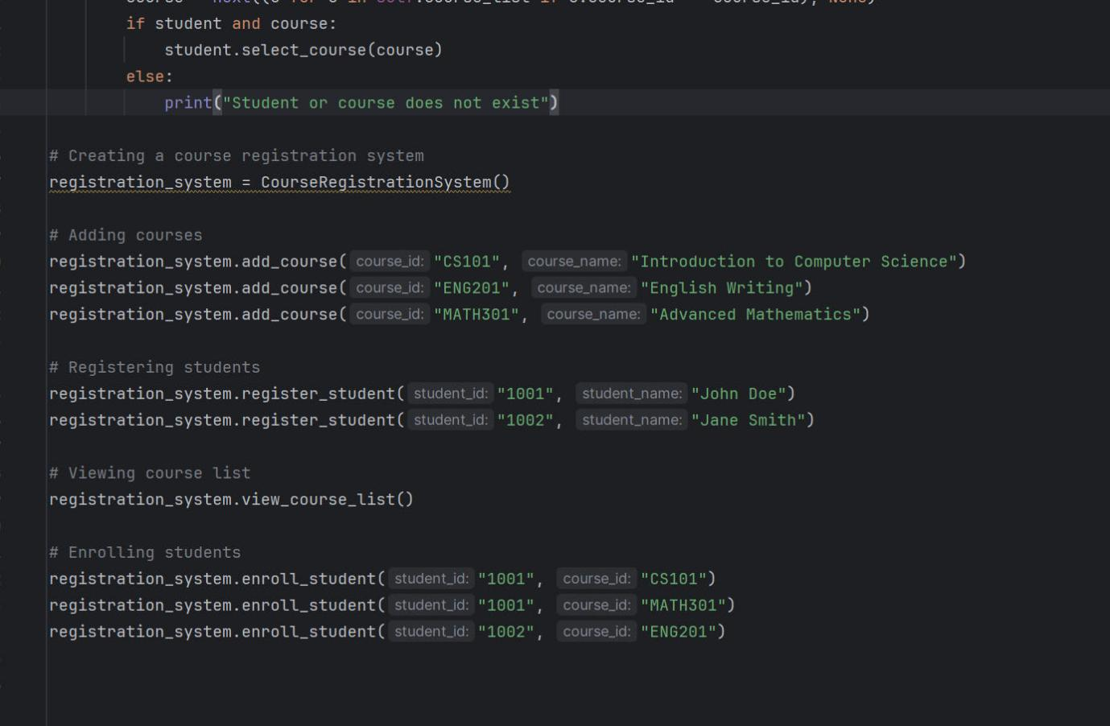

Figure30.0 Test code

pseudo-code can help us solve problems and reduce the complexity of the project. pseudo-code is more like the logical part of the code, it can create a code logic.

**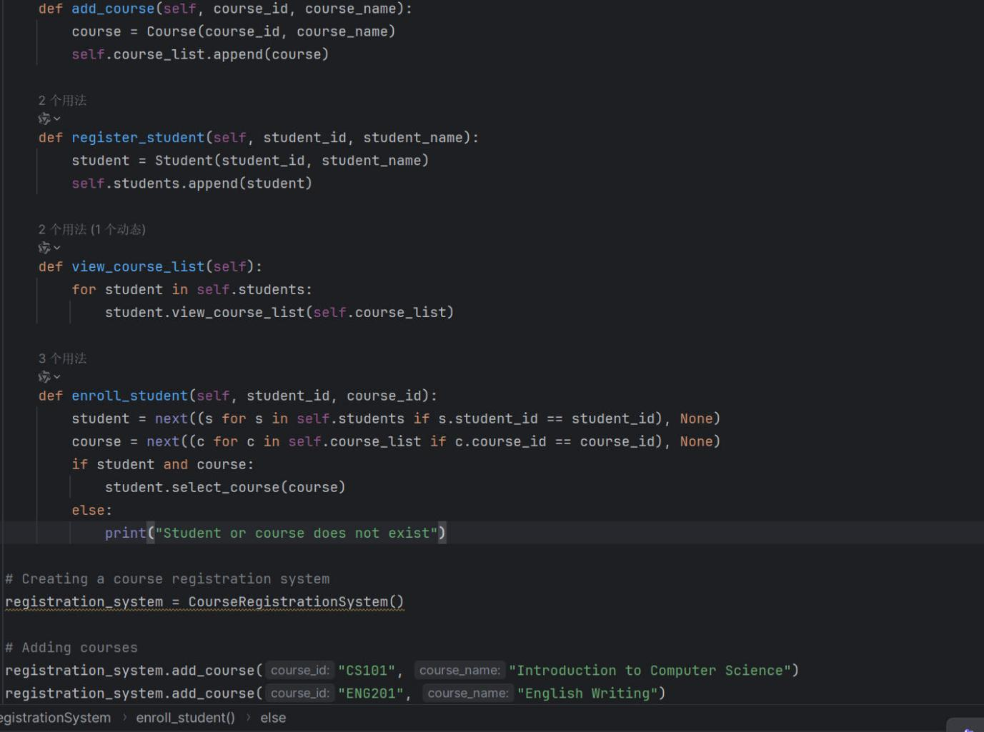**

Figure31.0 Test code

We wrote the necessary unit tests at every step of the project, and once the project was complete, we tested again to make sure the code was correct.

## Test flow chart

Figure32.0 Test flow chart

# Dependencies

## Critically discuss the educational administration system

With the rapid development of information technology, the field of education is also experiencing the change of information technology. As an important part of educational informatization, educational administration management system aims to improve the efficiency and quality of educational administration by means of information technology. More and more people have access to higher education. This has led to an increase in the number of students, which has brought great challenges to the traditional manual educational administration. The emergence of educational administration system has effectively solved this problem. The application of educational administration management system can help schools to meet international standards and improve the level of internationalization of education. The educational administration system can provide more fair and just educational administration services, such as fair allocation of teaching resources, fair assessment of teaching quality, etc., so as to promote the fairness of education.

## Risk Analysis

The educational administration system handles a large amount of sensitive data, including student personal information, grade records, etc. However, some systems have inadequate security that can lead to data breaches. Strengthening data encryption and security measures is a top priority.

The compatibility between different educational administration systems is poor, which leads to the difficulty of data exchange. The promotion of standardized data formats and interfaces is essential for data sharing across systems. Educational administration system often adopts a unified template, which is difficult to meet the personalized needs of different schools and teachers. Providing flexible configuration options and extensions enhances the applicability of the system.

# conclusion

Educational administration system plays a vital role in modern education system. It not only helps schools effectively manage student information, curriculum arrangement, teacher resources, etc., but also improves the efficiency and accuracy of educational administration. With the progress of technology, educational administration system has become a bridge connecting schools, teachers and students, providing more convenient and flexible education services.

The development course of educational administration management system

The development of educational administration system reflects the changes of educational technology and management ideas. From the early manual management to the current automatic system, the educational administration management system has undergone great changes. Especially with the popularization of the Internet and the development of cloud computing technology, the educational administration management system has become more intelligent and personalized.

Practical application of educational administration management system

Educational administration management system is widely used in practical educational environment. It can be used for student registration, course scheduling, grade management and many other aspects. For example, through the educational administration management system, students can easily query their own curriculum schedule and grades, teachers can easily manage course resources and student information, and schools can grasp the utilization of educational resources in real time.

Challenges and prospects of educational administration system

Although the educational administration system brings a lot of convenience, it also faces some challenges, such as data security, user experience and other issues. In the future, the educational administration system needs to further improve data security, optimize the user interface, and provide more personalized services. At the same time, with the development of artificial intelligence and big data technology, the educational administration management system will become more intelligent and personalized, providing more powerful support for education reform.

To sum up, educational administration system plays an irreplaceable role in modern education. Its development process reflects the changes of educational technology and management ideas, and its practical application is extensive and of great significance. Despite some challenges, the future of the educational administration system is still very broad.

# Practical inspiration and future research development

## Practical inspiration

Educational administration system improves efficiency and accuracy: Through automated processing, the educational administration system significantly improves the efficiency and accuracy of educational administration management, reducing the risk of manual intervention and error.

Information sharing and transparency: The educational administration system provides a centralized platform for teachers, students, parents and even communities to easily access and share educational information, increasing the transparency of educational activities.

Personalized Learning experience: The educational administration system can provide personalized learning paths and suggestions according to the learning situation, interests and needs of students to enhance the learning experience.

Data-driven decision making: The educational Affairs system collects and analyzes large amounts of data to support education policy makers and school administrators to make more scientific decisions.

## Future development study

Artificial intelligence and machine learning: Integrating AI and ML technology into the educational administration system can provide more accurate personalized learning and assessment, optimize teaching resources and course scheduling.

Mobility and learning analytics: The popularity of mobile devices has made the mobility of educational administration systems a trend, and learning analytics can help educators better understand students' learning patterns and difficulties.

Cross-platform integration: The future educational administration system may integrate multiple platforms and tools, such as LMS (Learning Management System), SIS (Student Information System), etc., to form a more complete and seamless education ecosystem.

Augmented reality and virtual reality: The introduction of AR and VR technologies will bring new interactive ways and immersive learning experiences to the educational administration system.

Block chain technology and decentralization: The application of block chain technology may change the way the data is stored and exchanged in the educational administration system, increasing the security and transparency of data, while decentralization may also challenge the existing education management model

# References

[A] [Jacobson et al., 2011]Jacobson, I., Booch, G., & Rumbaugh, J. (2011). The unified software development process. Reading, Mass.: Addison-Wesley Educationa.

[B] [Larman, 2005]Larman, C. (2005). Applying UML and patterns: an introduction to object-oriented analysis and design and iterative development. Upper Saddle River, N.J.: Prentice Hall Ptr.

[C] [Ross et al., 2016]Ross, J., Stevenson, F., Lau, R., & Murray, E. (2016). Factors that influence the implementation of e-health: a systematic review of systematic reviews (an update). Implementation Science, 11(1). doi:10.1186/s13012-016-0510-7.

[D] [Schürr et al., 2012]Schürr, A., & Rensink, A. (2012). Software and systems modeling with graph transformations theme issue of the Journal on Software and Systems Modeling. Software & Systems Modeling, 13(1), 171–172. doi:10.1007/s10270-012-0254-z.

[E] [Soni et al., 2017]Soni, M., & Berg, A. M. (2017). Jenkins 2.x continuous integration cookbook: over 90 recipes to produce great results using pro-level practices, techniques, and solutions. Birmingham, UK: Packt Publishing.

[F] [Dai et al., 2021]Dai, L., Wang, W., & Zhou, Y. (2021). Design and research of Intelligent Educational Administration Management System based on Mobile Edge Computing internet. Mobile Information Systems.

[G] [Chen, 2014]Chen, K. T. (2014). The design and implementation of educational administration system. Advanced Materials Research, 971–973, 2667–2670.

# Appendix

## IMG_256Annex A: Gantt Charts

# 

## Annex B: Introduction of team division

|  |  |  |
| --- | --- | --- |
| Student name | INDIVIDUAL MEMBER’S CONTRIBUTION | description |
| ZONGQI | a. Your tasks completed in the assignment.  b. Your team member’s task contribution to the assignment work  c. Favorable Collaborative Experience  d. Unfavorable Collaborative Experience and how you resolved?  e. Lessons Learnt -Learning Reflection | 100 WORDS |
| HU JIN | a. Your tasks completed in the assignment.  b. Your team member’s task contribution to the assignment work  c. Favorable Collaborative Experience  d. Unfavorable Collaborative Experience and how you resolved?  e. Lessons Learnt -Learning Reflection | 100WORDS |
| WENHAO | a. Your tasks completed in the assignment.  b. Your team member’s task contribution to the assignment work  c. Favorable Collaborative Experience  d. Unfavorable Collaborative Experience and how you resolved?  e. Lessons Learnt -Learning Reflection |  |
| YIFAN | a. Your tasks completed in the assignment.  b. Your team member’s task contribution to the assignment work  c. Favorable Collaborative Experience  d. Unfavorable Collaborative Experience and how you resolved?  e. Lessons Learnt -Learning Reflection |  |